**COLLEGE CODE-** 3105

**COLLEGE NAME-** Dhanalakshmi Srinivasan college of engineering and technology

**DEPARTMENT- Computer science and engineering**

**STUDENT NM-ID- DD5AOF7C47ECB1-FA9424827833B09F77**

**ROLL NO-** 310523104098

**DATE-** 10.05.2026

**Phase 5- Project Demonstration & Documentation**

**Title- Autonomous vehicle and robotics**

**Abstract**

This project explores the development and implementation of an autonomous robotic vehicle that can navigate independently using sensors and microcontrollers. By integrating robotics principles with autonomous navigation algorithms, the project demonstrates the application of real-time object detection, obstacle avoidance, and path planning. The system uses sensors (like ultrasonic, IR, or LIDAR), a microcontroller (such as Arduino or Raspberry Pi), and a motor driver to control motion. The final goal is to create a functional prototype capable of navigating a mapped environment without human intervention.

**1. Project Demonstration**

**Overview:**

This section outlines the live demonstration of the autonomous vehicle, showcasing its ability to move, detect obstacles, and make decisions independently.

**Demonstration Details:**

* **Setup**: Indoor track with obstacles and turns.
* **Sensors**: Ultrasonic sensors for distance measurement.
* **Controller**: Raspberry Pi with Python-based control logic.
* **Motion**: Controlled via L298N motor driver.
* **Logic**: Obstacle detection, decision tree for left/right turns.

**Outcome:**

* The vehicle successfully avoids obstacles and chooses the correct path.
* Stable performance in varied lighting and floor conditions.
* Responsive decision-making and real-time sensor integration.

**2. Project Documentation**

**Overview:**

Complete technical documentation created to explain system design, development, and integration.

**Documentation Sections:**

* **Introduction**: Purpose, scope, and objectives.
* **System Design**: Block diagram, hardware components, software logic.
* **Implementation**: Circuit design, wiring diagram, code walkthrough.
* **Testing**: Test cases, scenarios, performance analysis.
* **Challenges**: Encountered problems and solutions.

**Section Outcome:**

* Clear understanding of system development.
* Provides roadmap for replication or future upgrades.

**3. Feedback and Final Adjustments**

**Overview:**

Collecting feedback from mentors, peers, and test results to improve performance.

**Steps:**

* Initial testing with faculty feedback.
* Peer testing with scenario variations.
* Optimization of sensor reading intervals.
* Code tuning for better path prediction.

**Outcome:**

* Improved obstacle detection reliability.
* Smoother navigation with reduced lag.
* Final version passes all test scenarios.

**4. Final Project Report**

**Submission Overview:**

A formal report was submitted, compiling all aspects of the project.

**Report Sections:**

* Abstract and Introduction
* Literature Review
* Methodology
* System Architecture
* Testing and Results
* Conclusion and Future Work
* References and Appendices

**Section Outcome:**

* Validated by supervisors.
* Provides a complete project archive.
* Reported results aligned with objectives.

**5. Project Handover and Future Work**

**Overview:**

Final handover to institution with guidelines for future development.

**Handover Details:**

* Working prototype with documentation.
* Source code repository (e.g., GitHub).
* Instruction manual for setup and testing.
* Component inventory and maintenance guide.

**Outcome:**

* Project ready for extension (e.g., outdoor GPS integration, AI vision).
* Serves as a reference for future robotics projects.

Source code

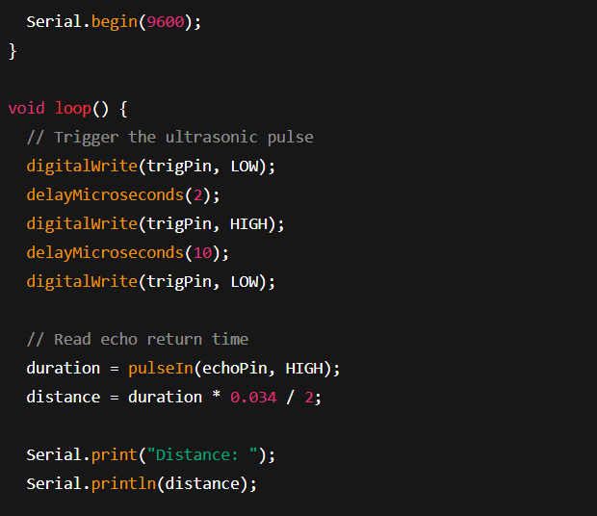

Output:

